Manufacturing of Pasta

Homework #7: Self Selected Homework

Madelyn Langin

November 10, 2017

MEEG453: Manufacturing Processes and Systems

Summary:

The pasta eaten today is produced with heavy machinery and manufacturing technology. The manufacturing of pasta begins with creating the dough and is completed when the pasta is dried and packaged. There are many quality and health standards to be met by the manufacturer to produce an acceptable product. The food industry is one of the largest manufacturing industries and the business aspects of food production are unique to the industry. These topics are discussed in the following report as well as the process’ impact on engineers.

Table of Contents

Main Body.......................................................................................................................................1

History.................................................................................................................................1

Raw Materials......................................................................................................................1

Manufacturing Process and Equipment...............................................................................1

Safety in Manufacturing......................................................................................................3

Environmental Impacts........................................................................................................3

Business and Economics..................................................................................................................3

Relevance to Engineers....................................................................................................................3

Learnings..........................................................................................................................................4

References........................................................................................................................................5

Langin 1

***History***

Pasta has become a staple of the American diet. Its ease of storage and the general ease of cooking makes it appealing to consumers. Though there are numerous theories as to where pasta originated from, it is believed to have been created as early as the 13th century. There were many cultures that had a variety of noodles incorporated into their meals. At one point pasta dishes “[combined] sweet, savory, and spicy flavors” (Lopez). When it was first created, pasta dishes were considered a dish for the wealthy but it quickly became more common as meat became scarce in Italy.

***Raw Materials***

The basis of most pasta noodles is the flour of durum wheat. This dough can be used to create over 200 types of pasta. Flour of durum wheat is “used to manufacture paste and non-paste food products” (North Dakota). Pasta is considered a paste product, because it is made with a mixture of durum flour and water, shaped, and cooked or dried. Non-paste products are those such as cooked bulgur and frekeh.

In a plant environment, the durum flour is handled as a bulk solid. The flour is dust-like in nature and is composed of small uniform particles. Creating the dough is the first step of the manufacturing process. Typically the durum flour is stored in a silo and an operator will control its automated flow directly into the mixer. The durum flour is then mixed with a specific amount of water before it can be processed further (“How It’s Made”). Certain types of pasta produced may also contain eggs, salt, or other seasonings.

***Manufacturing Processes and Equipment***

The first industrial processing of pasta was in the 1800s. Since then, many mechanical and technological development have improved the process and its ability to mass produce pasta. The current processes used to produce pasta are in fact similar to the production of paper and is heavily automated.

Mixers

The dough is created in an automated mixing machine with the durum flour and water. The water content is of particular importance to correctly mix the dough. Typically the moisture content is 31% and is reduced as the pasta is processed. A benefit of modern pasta processing is the ability to remove air bubbles in the pasta by using a vacuum chamber. Air bubbles in the pasta would “diminish the mechanical strength and give the finished product a white, chalky appearance” (EPA).

Extruders

Depending on the type of pasta to be made, the dough is either formed into sheets or pressed through dies.

Once mixed, the dough can be extruded to form sheets, which are then processed to form their particular pasta shape. The extrusion auger is the most important part of the extrusion process because it “not only forces the dough through the die, but it also kneads the dough into homogeneous mass, controls the rate of production, and influences the overall quality of the

Langin 2

finished product” (EPA). If the dough is not extruded uniformly, the pasta pieces would cook differently. This would then become a quality issue, which would add time and cost the company. The extrusion barrels are also important in handling the dough, because they help regulate the temperature if the dough gets too hot. After the sheet of dough is rolled to the correct thickness, the pasta is cut into its final shape. This process is typically automated and machinery varies with each pasta type. For instance, farfalle is formed row by row and simultaneously cut and folded to form individual pieces. But fusilli is formed through a die.

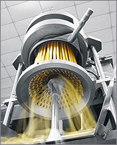

If the dough is not rolled into sheets, it will be pressed through a die to form more uniform pasta shapes, such as rigatoni, penne, or fusilli. Because the die is the tooling for this process, it is typical for one company to make several varieties of pasta, because the die is the only piece to be changed in the extrusion process.

**Figure 1**: Pasta Extruder

Drying

The dough then needs to go through a critical drying process. Similar to the production of paper, the dough must be dried at a certain rate to lower the moisture content without making it too brittle. If the dough is dried too quickly it will weaken the pasta and crack. However, if the pasta is dried too slowly it may spoil. The pasta is meant to be dried to about 12% water content so that it “will be hard, retain its shape, and store without spoiling” (EPA). Predrying is sometimes used to prevent the pasta sheets from sticking to one another by having a hard exterior on the sheet and a doughy interior. This allows for ease of handling prior to the final drying steps. The properly dried pasta will be firm yet flexible after the drying process is complete.

Packaging

The critical means of packaging for pasta is protection and containment. The packaging should “[keep] the product free from contamination, [protect] the pasta from damage during shipment and storage, and [display] the product favorably” (EPA). The typical package of pasta is either a cellophane bag or a box. The bag is a type of form-fill-seal packaging where the dried pasta is fed into the bag before it is automatically sealed and cut from the line. The box is made of cardboard and is a type of folding carton. Boxes are sometimes the better packaging option because they are “easy to stack, provide good protection for fragile pasta products, and offer the opportunity to print advertising that is easier to read than on bags” (EPA).

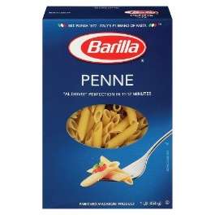 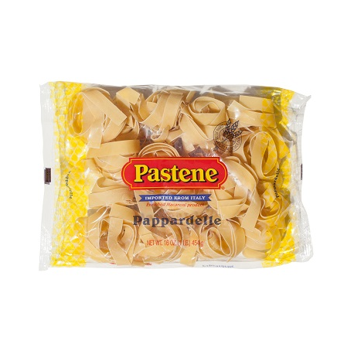

**Figure 2**: Boxed penne pasta and bagged pappardelle

Langin 3

***Safety in Manufacturing***

The primary goal of safety in the food industry is to make a safe and edible product. The Food and Drug Administration, also known as the FDA, specifies a set of requirements with the production of pasta. The FDA outlines the definitions of each type of pasta using dimensions. For instance, they regulate that all spaghetti much be between 0.06 and 0.11 inches in diameter (CFR). Additionally, they specify which marketing terms can be used for certain products. If a pasta is marketed as enriched, it must have the appropriate amounts of “thiamin, riboflavin, niacin, folic acid, and iron” (Registrar Corp).

Another safety item is the durum flour used to make the dough. Since it is a bulk solid made of small dust-like particles, it has the potential to explode if particles are airborne. There is not a lot of data on this in the past, but the process is still designed to properly handle this hazard (EPA).

***Environmental Impact***

Pasta production, while containing minimal ingredients, is one of many manufacturing processes that is looking to improve its environmental impact. One article published in the Water Resources and Industry Journal looked at the water footprint of Barilla pasta production. Due to the growing population and the difficultly of obtaining freshwater, companies such as Barilla are looking to lower their water footprint. A water footprint is similar to a carbon footprint and indicates how much water is used to create one unit of pasta, while accounting for a variety of variables in the water’s consumption. This affects not only the company looking to lower their water footprint, but their suppliers as well. Barilla was able to reduce their water footprint by creating 1 kg of pasta with between 1.336 and 2.847 liters of water (Water Footprint).

***Business and Economics***

Given that pasta production is a part of the food industry, it is heavily influenced by the production of raw ingredients. Pasta cannot be made if the manufacturer does not have quality ingredients to begin processing. For instance, with the avian influenza in 2015, the price of liquid eggs increased. The cost increase of liquid eggs then increased the price of pastas that contained eggs (McKewen). Pasta itself is one of the largest portions of the food market. In 2013, the cookie, cracker, and pasta production had $23,533.9 million in revenue (“Food Industries’ Healthy Margins).

***Relevance to Engineers***

The significance of this topic for a beginning engineer is learning more about the equipment and how best to process the material. The pasta is very fragile throughout the process and all steps must be executed perfectly to produce a quality product. There is specialized equipment throughout the process, most of which would be unfamiliar to a beginning engineer. The new engineer would need to spend time becoming familiar with the specialized equipment before suggesting changes or improvements to the process.

The significance of this topic for an experience engineer is unique processing challenges. Assuming the experienced engineer is already familiar with the equipment, the pasta production would serve as an interesting challenge. Since the pasta is so delicate, any process improvements

Langin 4

would be technically oriented. An experienced engineer would be looking to improve the speed or quality to produce more product. Both of these changes would require intimate knowledge of the systems in place and what technical aspects would need to be altered. For instance, Barilla, one of the largest pasta companies, recently announced their use of 3D printers to create pasta (Barilla Group). This is evidence that all industries are constantly advancing with new technology. An experienced engineer would recognize this significance and work to scale-up this production model.

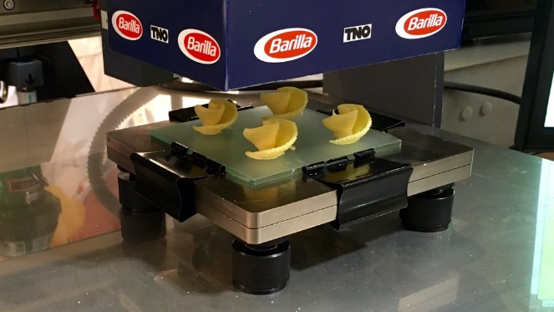

**Figure 3**: Barilla Pasta 3D Printer

***Learnings***

I learned more about the food industry and how the production is scaled up.

This assignment was a good way to develop a further understanding of the manufacturing processes and equipment discussed in class. I found the food manufacturing chapter particularly interesting and wanted to learn more about it and how the industry manages their safety and quality. I chose pasta because I was interested in learning more about how it was mass produced. I’ve seen machines for the average consumer, but never considered how it would be scaled up to a full manufacturing process. I was intrigued by the complexity in the drying process. It was interesting to see the parallels between the pasta production and paper production. The drying process seemed to be the most critical because it determined the pasta’s final quality.

Langin 5

**References**

“CFR - Code of Federal Regulations Title 21.” *Accessdata.fda.gov*, FDA, 14 Aug. 2017, www.accessdata.fda.gov/scripts/cdrh/cfdocs/cfcfr/CFRSearch.cfm?fr=139.110.

“Food Industries' Healthy Margins.” *IBIS World*, 23 May 2013, www.ibisworld.com/media/2013/05/23/food-industries-healthy-margins/.

“How It's Made Pasta.” 24 Sept. 2010, www.youtube.com/watch?v=75bfUmqx82s .

“Italian Pappardelle - 16oz Bag.” *Pastene Store*, store.pastene.com/pasta-rice-and-polenta/192-italian-pappardelle-16oz-bag.html.

L. Ruini, M. Marino, S. Pignatelli, F. Laio, L. Ridolfi, Water footprint of a large-sized food company: The case of Barilla pasta production, In Water Resources and Industry, Volumes 1–2, 2013, Pages 7-24, ISSN 2212-3717, https://doi.org/10.1016/j.wri.2013.04.002.

(http://www.sciencedirect.com/science/article/pii/S2212371713000061)

Lopez, Alfonso. “The Twisted History of Pasta.” *National Geographic*, 1 Nov. 2016, www.nationalgeographic.com/archaeology-and-history/magazine/2016/07-08/daily-life-pasta-italy-neapolitan-diet/.

McKewen, Ellen. “CMTC Manufacturing Blog.” *Challenges and Trends Facing Food and Beverage Manufacturers in 2016*, 21 Apr. 2016, www.cmtc.com/blog/food-and-beverage-manufacturing-trends-and-challenges-2016.

“North Dakota State University.” *Durum Wheat Products - Plant Sciences*, 11 June 2012, www.ag.ndsu.edu/plantsciences/research/durum/products.

“Pasta Extruder MAC 300 VR.” *Pasta Machines | Pasta Extruder*, Italpast, www.italpast.it/2009/macchine-alimentari/english/ExtruderMAC300VR.htm.

*Pasta Manufacturing*. EPA, Aug. 1995, www3.epa.gov/ttnchie1/ap42/ch09/final/c9s09-5.pdf++.

“PASTA OF THE FUTURE? IT'S PRINTED IN 3D BARILLA PREVIEWS ITS THE PROTOTYPE AT CIBUS 2016.” *Barilla Group*, 9 May 2016, www.barillagroup.com/en/press-releases/pasta-future-it%E2%80%99s-printed-3d-barilla-previews-its-prototype-cibus-2016.

“Penne Pasta - 16 Oz.” *Target:Expect More. Pay Less.*, www.target.com/p/barilla-penne-pasta-16-oz/-/A-13156215.

“Using Your Noodle to Understand Pasta Names.” *Using Your Noodle to Understand Pasta Names | Registrar Corp*, 4 Feb. 2014, www.registrarcorp.com/fda-standard-of-identity-pasta/.